Statistics Lecture 3.4: Finding Z-Score, Percentiles and Quartiles, and Comparing Standard Deviation

Measures of relative standing.
Comparing measures between or within datasets.

Z-score:
The number of standard deviations a data value () is away from the mean.

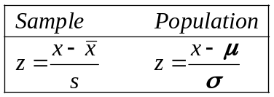

Allows comparisons of the variation in two different samples

- LBJ’s height is 76 inches
Mean height for presidents is 71.5 inches.
Standard deviation is 2.1
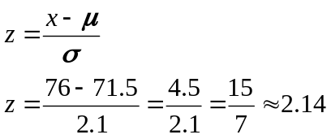
- Shaq’s height is 86 inches
Mean height for Basketball players 80 inches.
Standard deviation is 3.3
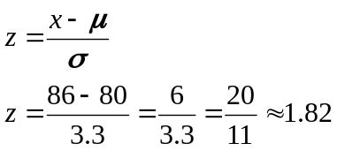

Who is relatively taller?
LBJ his z score is larger.

A z-score between -2 and 2 is considered usual.
A z-score less than -2 and greater than 2 is considered unusual.

The larger the z-score, in terms of absolute value, the rarer the data value.

Example
LBJ plays for the Miami Heat.

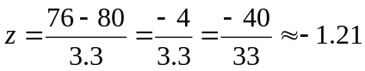
Usual height for the basketball player

Example
Professor Leonard plays for the Miami Heat.

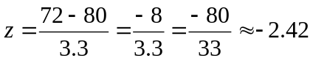

Unusual height for the basketball player

Quartiles:
1st quartile: 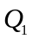 bottom 25% of sorted data
2nd quartile: 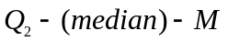 bottom 50% of sorted data (is the median)
3rd quartile: 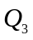 bottom 75% of sorted data
No 4th quartile: 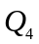 NOT Relevent.

Example
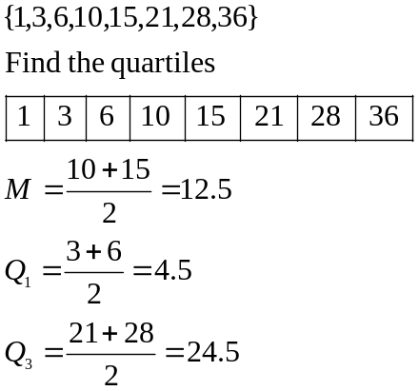

Example
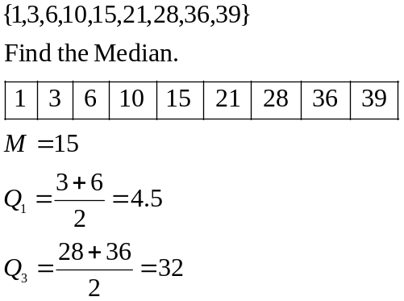

Percentiles:
Separates data into 100 parts. Therefore, there is 99 percentiles.
Compares a data value to everyone else as a percentage.

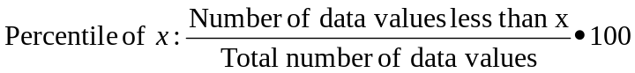

Example
You scored 87/100 on a test 39 people scored lower than you. There are 54 people in the class
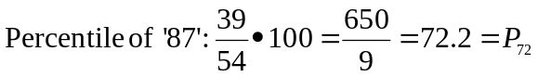

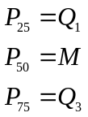

Inter quartile Range:
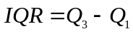 Represents middle 50% of the data

Box plot
5 number summary
- Minimum value
- Maximum Value
- Median

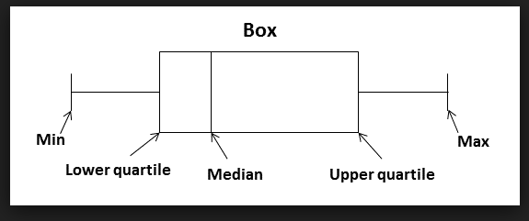
Example
1, 4, 5, 5, 7, 9, 12, 13, 13, 15, 21
Outliers:
Find the IQR
Multiply the IQR by 1.5
